

Ascendion AVA Digital Ascender

**TRIAL ACCESS INSTRUCTION MANUAL**

**INDEX**

### INSTRUCTIONS 2

**Guest Access 2**

**Digital Ascender Use cases 3**

1. Product Management 3
2. Quality Engineering 4
3. Plugins 5
4. Conversion 6
5. Ask Me 10

**Instructions**

**Guest Access**

* 1. Upon receiving the email with the subject "*Ascendion invited you to access the applications within their organization*," please click the "Accept Invitation" link from the email address "*Microsoft Invitations on behalf of ascendion* [*invites@microsoft.com.”*](mailto:invites@microsoft.com)
  2. Activate the Guest access by utilizing your Microsoft account and the Microsoft Authenticator application.
  3. After successfully activating the Guest access, navigate back to the same email and click on the provided application link.

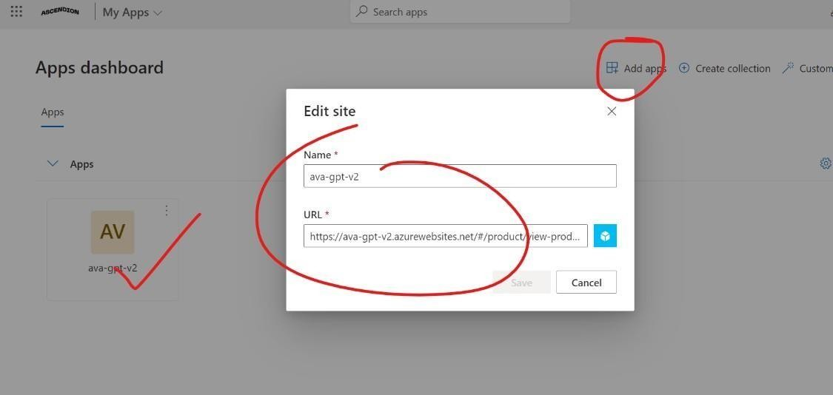

* 1. Once you land on the designated page, click the "Add Apps" button. In the provided fields, enter the Name* as "**digital-ascender-Highmark Thryve**" and the URL* as https://digital-ascender-portal-highmark-thryve.azurewebsites.net/newportal/
  2. After adding the application, click on the " **digital-ascender-Highmark Thryve** " application to access the Ascendion Digital Ascender demo version.

# Digital Ascender Use cases

## Product Management

1. Upon accessing the Product Management Page, begin by selecting the appropriate Domain and Application Type from the provided options.

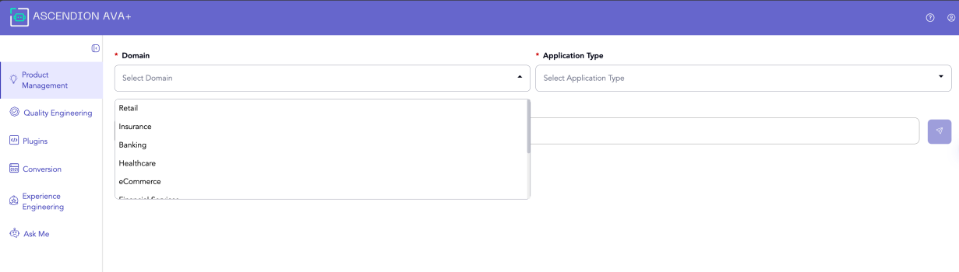

1. In the designated Text input box, enter the EPIC and a concise description of the desired feature, then click the "Arrow" button to proceed.
2. Digital Ascender will analyze the provided feature description and generate relevant user stories, presenting them for your review.

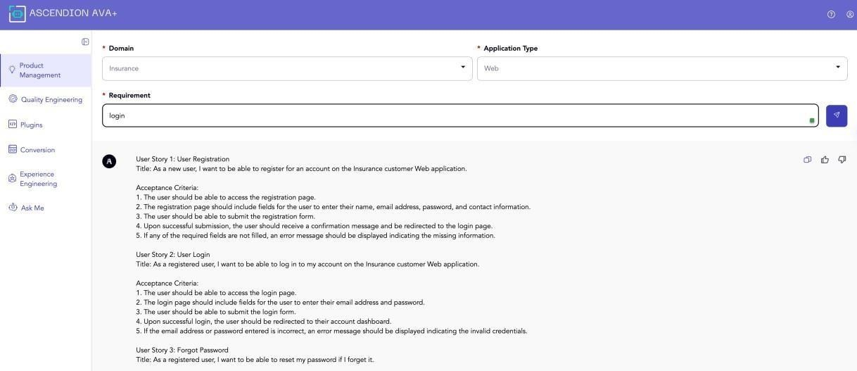

## Quality Engineering

Test Scenario Generation

1. From the left navigation panel, select the "Quality Engineering" option. Once on the Quality Engineering page, choose the relevant Domain and Application Type from the provided dropdowns. Then, enter the details of the user story in the "Requirement" field. When ready, click on the "Arrow" button to proceed.

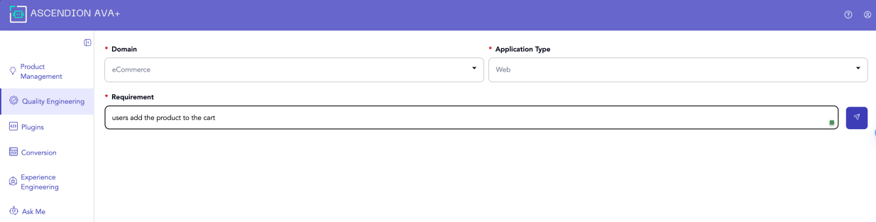

1. Digital Ascender (DA) will generate and present the relevant Test Scenarios in the widely adopted Gherkin format, which follows the Given-When-Then structure.

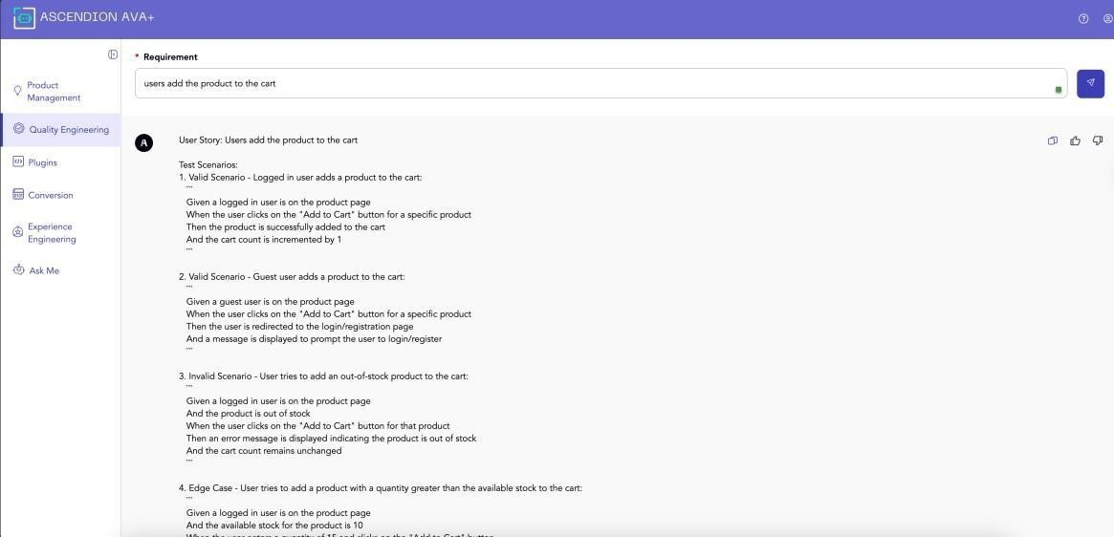

## Plugins

This feature is intended for use by all members of the development team."

1. From the left navigation panel, select the "Plugins" option. Users will have access to a comprehensive list of available plugins, displaying the most recent versions available for download.

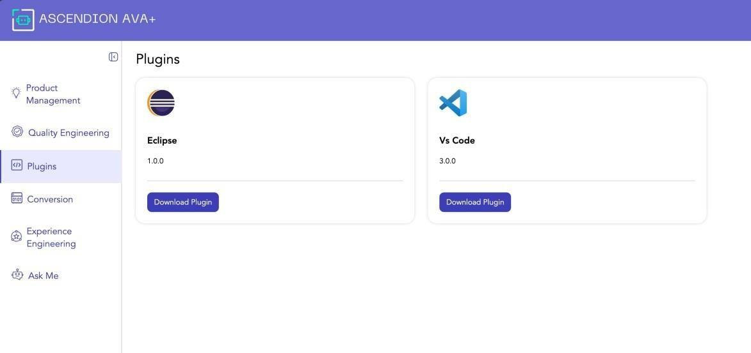

1. Developers can access Digital Ascender (DA) use cases within the Plugin by navigating to the Code section, right-clicking on the desired code snippet, and selecting the applicable use case from the provided options.

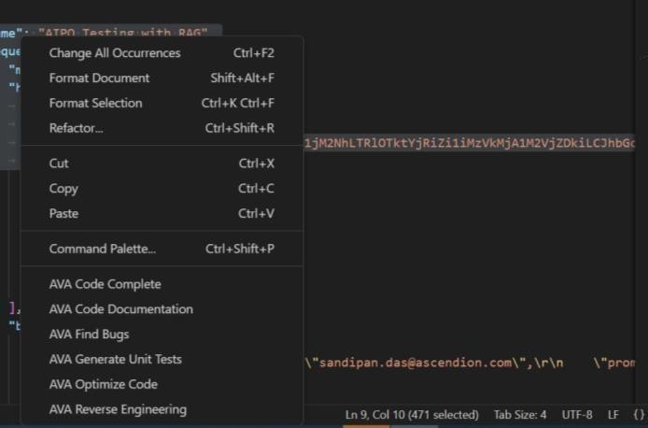

Fig: Command Options from Visual Studio Code Plugin

1. AVA Code Complete - This use case utilizes natural language processing to comprehend the selected code segment and assist in completing the remaining portions intelligently.
2. AVA Code Documentation - This feature aids developers in generating inline documentation for their code, including brief descriptions of variables and other relevant details.
3. AVA Find Bugs - This use case leverages advanced algorithms to analyze the selected code and identify potential bugs or issues.
4. AVA Generate Unit Tests - This use case automatically generates relevant unit test cases for the selected code, facilitating thorough testing and validation.
5. AVA Optimize Code - This use case employs sophisticated techniques to optimize the selected code, improving its performance, efficiency, and maintainability.
6. AVA Reverse Engineering - This use case translates code into plain English, aiding in comprehension and knowledge transfer, particularly for non-technical stakeholders.

## Conversion

This use case offers Conversion and Upgradation is for Angular code update and code Conversion.

1. Conversion:

Under conversion select a use case: 1) code to code and 2) code to document.

### code to code

* Select the appropriate source code language and the desired destination language for the conversion process from the provided options.
* In the designated "Code Conversion" box, paste or enter the source code that needs to be translated.
* Once the code has been entered, click the "Convert" button to initiate the translation process.
* Upon successful conversion, the translated code will be displayed, allowing you to copy and utilize it for further purposes as needed.

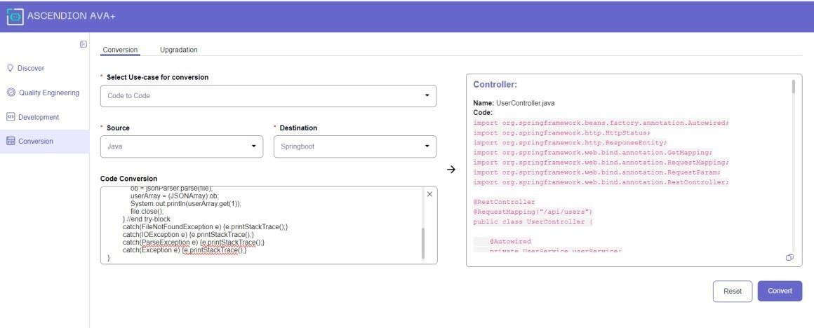

### Code to Document

1. From the provided dropdown menu, select the "Code to Document" option.
2. Choose the appropriate source language from the designated dropdown.

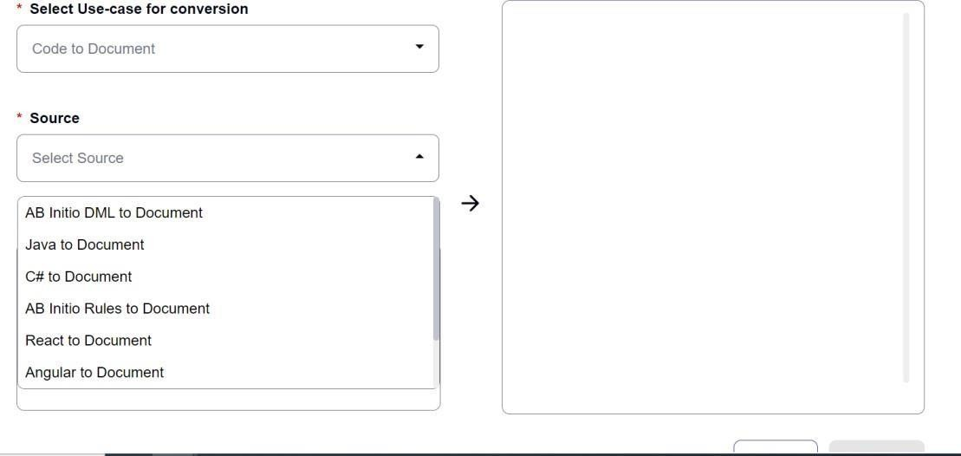

1. In the provided code box, paste or enter the code that needs to be documented.
2. Once the code is ready, click the "Convert" button to initiate the documentation process.
3. After successful conversion, the generated documentation will be displayed, allowing you to copy and utilize it as required.

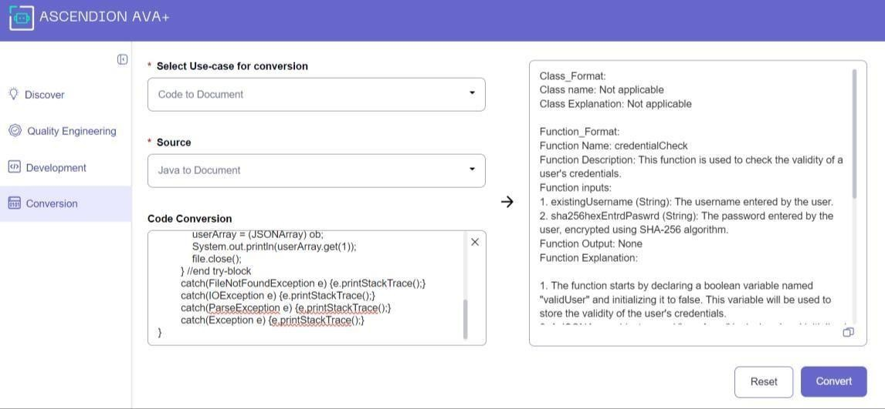

1. Upgradation
2. From the left navigation panel, select the "Conversion" option. Once you have accessed the Conversion Module, navigate to the "Upgradation" tab.

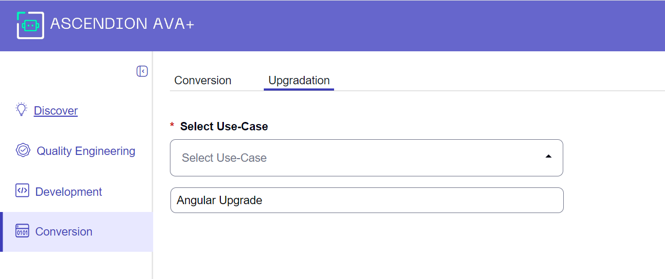

1. Under the Upgradation tab, choose the "Angular Upgrade" use case to convert Angular code by uploading a ZIP file. Specify the desired version upgrade, for example, from version 11 to version 17, or from version 5 to version 17.

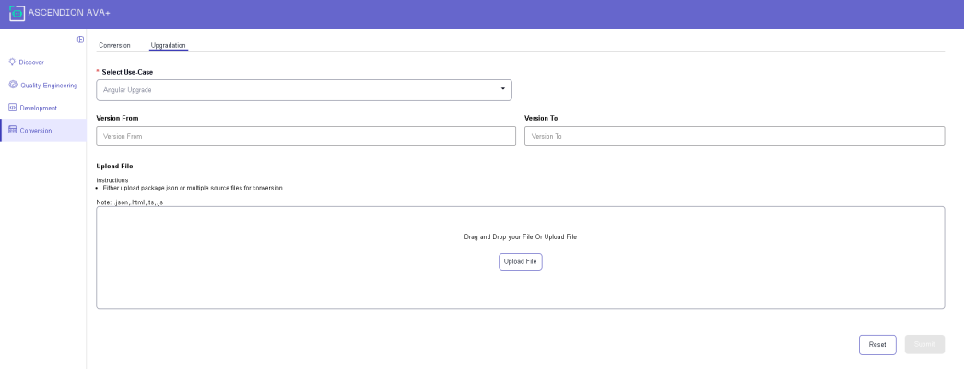

1. Upload the ZIP file containing the Angular code that needs to be upgraded.
2. After uploading the file, submit the request by clicking the appropriate button.

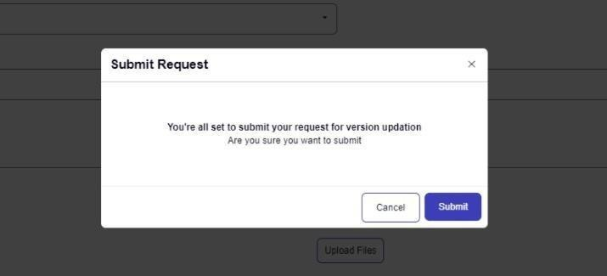

1. Upon submission, a request ID will be generated. Confirm the submission by clicking the "OK" button.

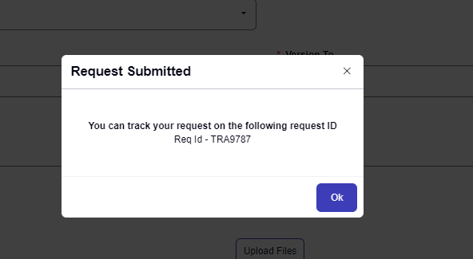

1. Once the conversion process is complete, you can download the updated Angular file by clicking on the "Download" icon under the "Action" column.

## E. Ask Me

This section is a free form chat to understand about DA. You can ask about DA features, use cases, architecture and other DA related questions here.

